S1 midi trigger instructions.
We have provided two ways to control your G2 using an IOS device. Both methods use the standard midi controller App S1 Midi trigger, which can be found on the apps store.
Controller mode:
You need to tell your G2 you are using this mode so it knows what to do with the incoming midi.
Hold down foot switch 5 and press the Phase button to enter special function 5. When in this mode press the out 2 button to select Controller mod then exit by pressing the phase button again.
This has a simple picture of the G2 foot switches with pre and post volume controls.
You use this controller mode just the same as using your G2, select Banks using the + Engage bank button.
You can also directly select the master preset, reset and test the lights on your G2.

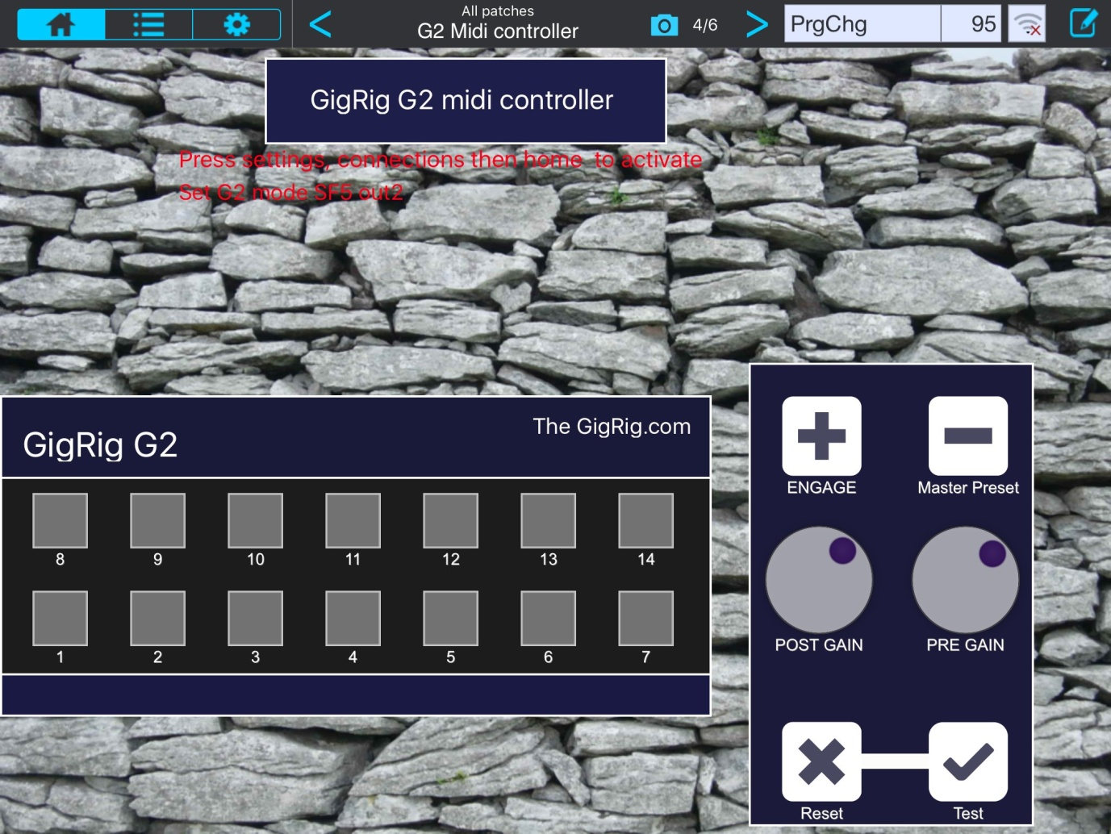

Now we have direct mode.
In this mode every preset can be accessed, in every bank, directly using one midi Program change message.
You need to tell your G2 you are using this mode so it knows what to do with the incoming midi.
Hold down foot switch 5 and press the Phase button to enter special function 5. When in this mode press the out 1 button to select Direct mod, then exit by pressing the phase button again.

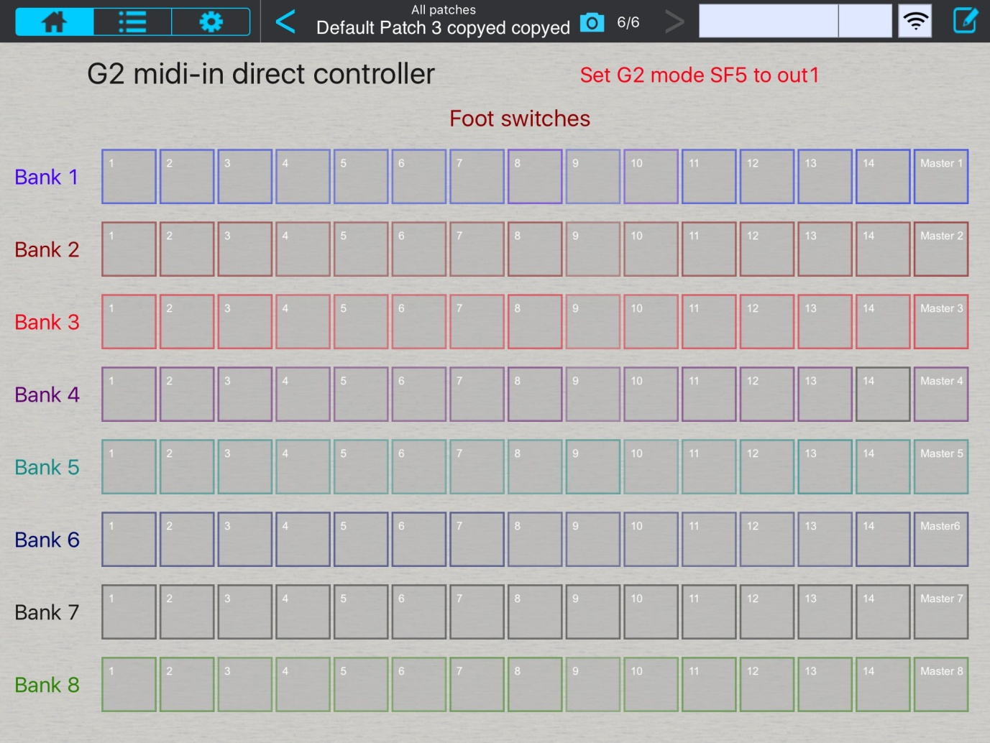

G2’s midi map is as follows.
